The Box Daddy™ ©

**User Manual**

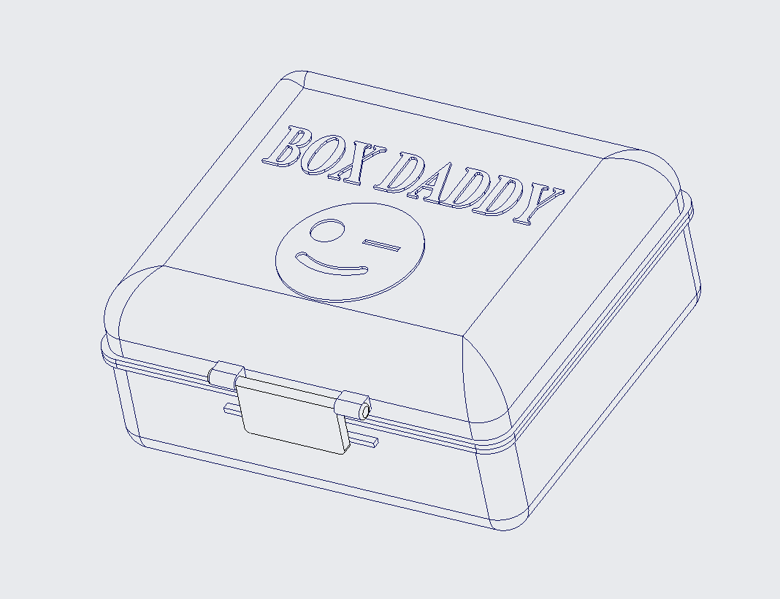

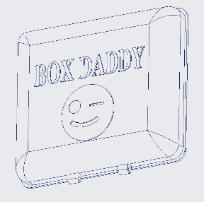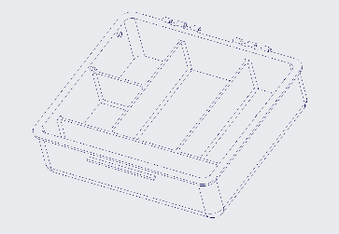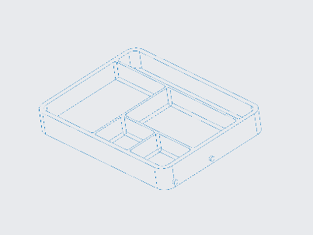 [06]

[04]

[05]

[01] [02] [03]

Please read the following manual before operating the Box Daddy™. The Box Daddy™ is not a toy nor food. Please keep out of reach of small children.

The Box Daddy™

brought to you by ©

Table of Contents

Assembly…………………………………………………………………………3

Intended Use…………………………………………………..………………..4

Maintenance……………………………………………………………………..5

Warranty Information………………………………………..………………..6

Service Center…………………………………………………………………..7

**Assembly**

Included Parts:

* [01] Lid (x1)
* [02] Base (x1)
* [03] Tray (x1)
* [04] Latch (x1)
* [05] Hinge Pin (x2)
* [06] Connector (x4)

The Box Daddy™ will come pristinely packaged from one of our distribution centers. However, in the unlikely event of complications you as a consumer have two options:

1. if during shipping the box parts become separated, you should be able to attach the flexible plastic hinges yourself.
2. if you cannot assemble it or your Box Daddy™ arrives broken, you can send it back and receive a new Box Daddy™ free of charge.

In Case A (where the box parts are separated), the Box Daddy™ is assembled by connecting:

1. the base [02] to the lid [01] by the hinges closest to the name of the box
   1. Diagram

      Description automatically generatedwith both hinge pins [05] inserted into the hinge
2. the latch [04] to the lid [01] by the hinges closest to the emoticon of the box
3. one end of each connector [06] onto the pins on both outer sides of the tray [03]
4. the other end of each connector [06] onto the pins on both inner sides of the base [02]

Figure 1.1. Box Daddy™ Explosion View

**Intended use**

The Box Daddy™ is designed to hold your hygiene products in a compact water-resistant space while traveling. The lid of the Box Daddy™ is clear for your convenience. The pop-up tray design allows you to keep your utensils on a clean surface, preventing nearby bacteria from reaching your products. The divisions are to make sure your items stay organized. While you are not traveling the box can be used as a clean surface to place a multitude of objects.

Below, Figure 2.1. and Figure 2.2. are displayed as examples of where the common hygiene products can be placed.

Figure 2.1. Box Daddy™ with Products Side View

Figure 2.2. Box Daddy™ with Products Top View

**Maintenance**

Once the Box Daddy™ gets dirty it can be handwashed with dish soap and water or disinfecting wipes. Cotton swabs can be used for more intricate areas. After deep cleansing, the Box Daddy™ can be dried with a hand towel or air dried.

We recommend cleaning the product after every trip to prevent contamination and mildew.

**Do not disassemble** the Box Daddy™ during the cleaning process, to ensure you maintain the optimal state of the Box Daddy™. Disassembling the Box Daddy™ during cleaning may lead to weakness in the connectors and breakage of the joints. In the event of breakage before the end of the warranty, please contact your nearest service center.

**Warranty Information**

Thank you for your interest in utilizing a Just-In Case© product!

The Box Daddy™ has a **30-day** return policy, money-back guaranteed. If you are not 100% satisfied with the product, please contact our staff using the information listed in the Service Center section or through the Just-In Case© website.

This warranty **does** cover:

1. Damage during delivery
2. Breakage within **60 days**
3. Faulty product
4. Hinges
5. Latch
6. Tray
7. Connectors
8. Seal
9. Water damage

This warranty **does not** cover:

1. Any purposeful damage or alterations done to the Box Daddy™
2. Misplacement of product
3. Theft
4. Misuse

If any of the above listed in the “does not cover” section is done to the Box Daddy™, Just-In Case© are not responsible for a replacement.

**Service Center**

During the creation of this manual (2022), the following information is up to date. If there are changes or concerns, please refer to our website for our contacts.

Website:

<https://webpages.charlotte.edu/amcgowa3/finalproject.html>

Phone Number:

(704) BOX-DADD

Address:

9201 University City Blvd, Charlotte, NC 28223

**Operating hours** are **24/7** for optimal customer satisfaction.

**Group 23**

|  |  |
| --- | --- |
| Andrew McGowan  Commander/Treasurer  [Amcgowa3@uncc.edu](mailto:Amcgowa3@uncc.edu)  Noah Silverman  External Vice President  [Nsilverm@uncc.edu](mailto:Nsilverm@uncc.edu) | Thuy Nguyen  Internal Vice President  [Tnguy263@uncc.edu](mailto:Tnguy263@uncc.edu)  Carlos Soriano Moreno  Executive CAD Designer  [Csorian2@uncc.edu](mailto:Csorian2@uncc.edu) |